Lesson Plan Week #2 (Age 5+6) | Supplies: Capture the Target  Two different color standard balls, standard appropriately-sized putting clubs, multiple targets (at least 24 generally same sized targets), low profile cone tee markers.  Supplies: Full Swing Aim  Standard appropriately-sized full swing clubs, alignment rods, low profile cone tee markers, noodles for transition zones, safety hoops, standard practice balls.
Core Lesson: Using Good Judgment: Making Good Choices
Game/Activity: Capture the Target + Range
First Tee Commitment: Using Good Judgment
Golf Skill Category: Putt + Full Swing
Factor of Influence: Aim and Alignment
Golf Fundamental: Get Ready to Swing
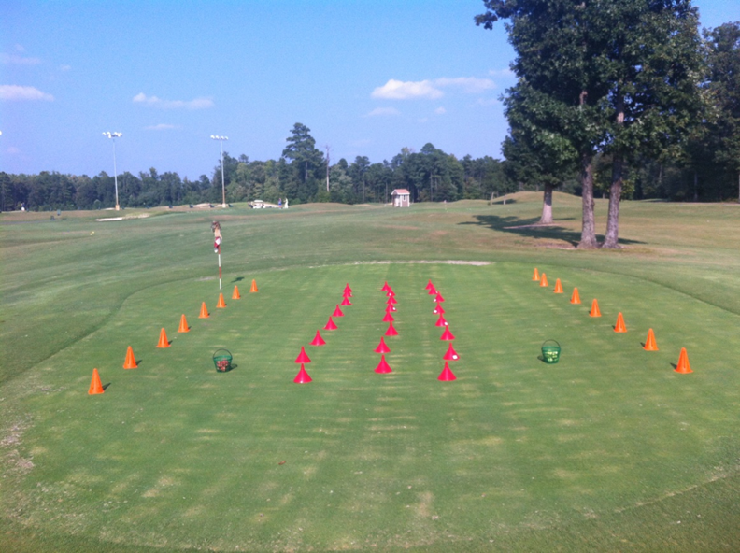
Capture the Target

Full Swing Aim

Warm Up: 10 Minutes
Caterpillar Race- Class will be divided into equal teams and each team will line up front to back behind a cone. The first player in the line holds the ball. Coaches will demo the game for the players. When coaches say start the players will begin moving the ball from the front to the back of the line by using the order of (over>under>side>side). When the last player gets the ball, he/she runs to the front and starts the order from the beginning (over>under>side>side). The line will move forward each time the player from the back runs forward. The winning team will be the first one that reaches a certain point marked by another cone. Begin with a small distance to travel and play another round and extend the distance if appropriate.

Lesson Preview: 5 Minutes
Lead coach will ask about the importance of selecting targets in golf. Also tease the capture the target game and the importance of using good judgment (making good choices).

Wrap Up 5 Minutes
Wrap Up Questions:
- How did class go today?
- What did you learn about golf today?
- What targets did you aim for? Why?
- How did you make good choices (use good judgment) while playing capture the target?
- How can you take what you learned about making good choices and use it away from the First Tee? Home or School?

Capture the Target (12 minutes and Transition) | Practice Range (12 Minutes and Transition)
Summary: Players will play a team game where teams are rewarded for working together as they putt and contact targets. | Summary: Players work in pairs as they make full swings and work on making good choices about their aiming.
Game/Activity Rules:  - Teams will be rewarded if a ball from their team contacts a target by removing that target and keeping it for their team  - Teams should be encouraged to collaborate and formulate a strategy as to what target they aim for in order to capture them maximum amount of targets  - The game will be played until the majority of targets are captured by a team  - Approximately same sized targets will be arrayed on the putting green  Game/Activity Play by Play:  - Class will be divided into two teams and assigned a safety zone.  - Coaches will demonstrate the safety process, golf skill and game  - Teams will have 2 minutes to come up with a team name  - Teams will begin hitting putts to the targets- one team at a time  - Players are allowed to drop their clubs after hitting and walk to pick up their ball plus target (if applicable) and then walk back to their station  - A target is captured by the first players ball that hits that target  - If multiple targets are contacted, then the first target that the ball hit is the only one counted | Game/Activity Rules:  - Players will practice their aim to different targets while making full swings  - Players will use the provided alignment stick to assist them with aiming their club and aligning their body to the targets they select  - Players will safely switch with their safety partner after taking their turn  Game/Activity Play by Play:  - The class will be divided into pairs and assigned a safety zone  - Coaches will demonstrate the safety process, the golf skill and game.  - Players will begin taking turns selecting targets and trying to aim/align  toward the targets  - Players will utilize the alignment sticks to assist with aim/alignment  - Players will hit 4 shots and switch with their safety partner
Coaching Tips & Objectives
Key Commitment Objective: Coaches will encourage players to make good choices (use good judgment) while aiming for targets.  Golf Objective: Coaches will give feedback to players regarding their aim and alignment as they attempt to hit targets while putting/ making full swings | Sample Coaching Questions:  - What target are you trying to hit?  - Does it help to aim at the target? Why?  - Is it helpful to make good decisions about targets? Why?

